Setting up the complete network interface by configuring services

Command 1 :ifconfig -a
Purpose of Command :display all the interfaces available
usage :ifconfig -a

Sample Input/Output :
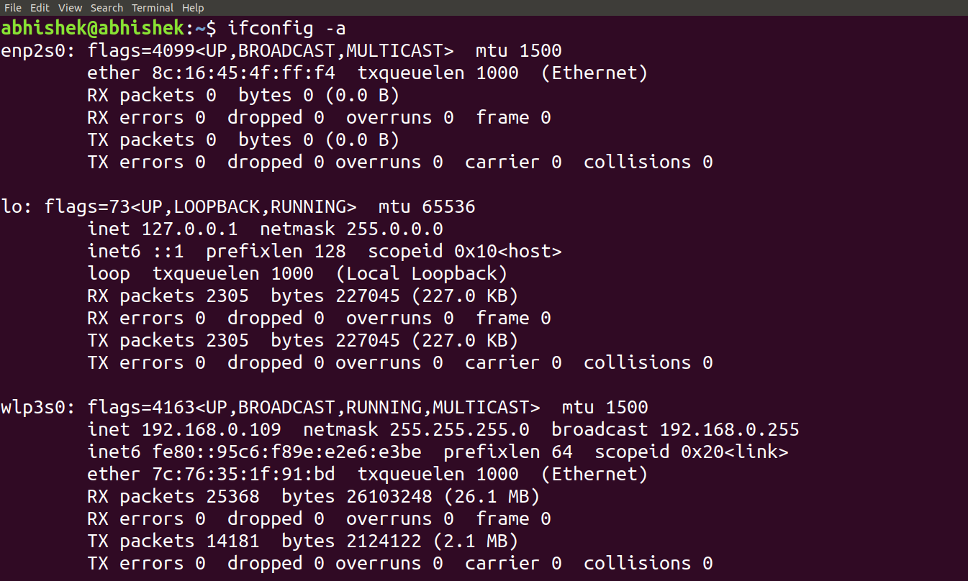
Command 2 :ifup
Purpose of Command :Enabale a Network Interface
usage :ifconfig <interface name> up #setting up network
or ifup <networkname>
Sample Input/Output :

Command 3 ifconfig
Purpose of Command :Assigning ip to a network interface
usage :ifconfig <interface name> <ip address>
Sample Input/Output :

Set Default Gateway

Command 4 :route add default gw .
Purpose of Command :Set default gate way.
usage :route add default gw <ip address>
Sample Input/Output :
Set DNS

Command 5 :
Purpose of Command :To set DNS server
usage :echo "nameserver 1.1.1.1" > /etc/resolv.conf
Sample Input/Output :
Command 6 : route
Purpose of Command :To show the routing table.
usage :
Sample Input/Output :
